Jon Janelle

MAT 500

***Chapter 9 Homework***

**(9.2A)**

The histograms for the estimated $μ$ differences, where K is constrained to be equal for all four groups, are shown below. The 95% HDI for $μ_{1}-μ_{2}$ is farther away from 0 than in Figure 9.16 because $μ_{1}$ and $μ_{2}$ are no longer correlated with $K_{c}$, which reduces the random variation in $μ_{1}$ and $μ_{2}$. When $K_{c}$ is chosen separately for each group, which is shown in Figure 9.19, there is a clear positive correlation between $K_{c}$ and $μ_{1}$ and between $K_{c}$ and $μ_{2}$. Since $K_{c}$ is chosen separately for each group, it is possible for the K for group 1 to be randomly chosen high while the K for group is low, or vice versa. The distribution for $K_{c}$ is highly variable, which is seen in Figure 9.19, and consequently variability is added into $μ_{1}$ and $μ_{2}$ because of the positive association. This added variability causes more extreme values of $μ_{1}$- $μ_{2}$ to be generated, which widens the HDI and pushes it closer to 0. Using the same mean K for all four groups reduces the association with $μ_{1}$ and $μ_{2}$. This reduces their variability and narrows the HDI, pulling it farther away from 0.

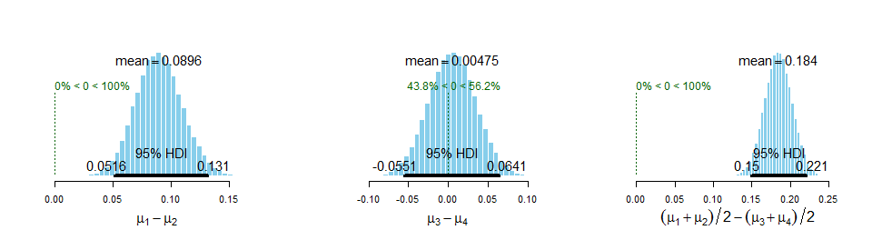

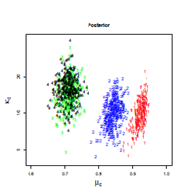 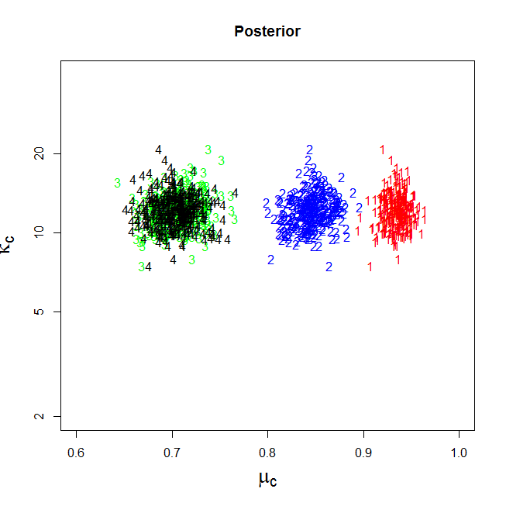

Left Panel of Figure 9.19

Different ${ K}_{c}$ for Each Group

Scatterplot of ${ K}_{c}$ Versus ${ μ}_{c}$ with

Same ${ K}_{c}$ for Each Group

**(9.2B)**

The histograms for the estimated $μ$ differences, where values of $K_{c}$ are mutually informed by an overarching distribution, are shown below. The 95% HDI for $μ_{1}-μ_{2}$ is farther away from 0 than when each group used the same K because there is less variability in the values of $K_{c}$. The HDI for $μ_{1}-μ_{2}$ is closer to 0 than when each group used independent values $K_{c}$ because there is greater variability in the values of $K_{c}$. When the variability in $K_{c}$ decreases, the effect of the correlation with $μ_{1} and μ_{2}$ is reduced, which reduces the variability in $μ_{1} and μ_{2}$. Similarly, when the variability in $K_{c}$ increases, then so does the variability in $μ_{1} and μ_{2}$. Since the variability in the values of $K_{c}$ is greater than when the same K is used, but less than when K are independent, it seems reasonable that the effect on $μ_{1}-μ_{2}$ falls in the middle.

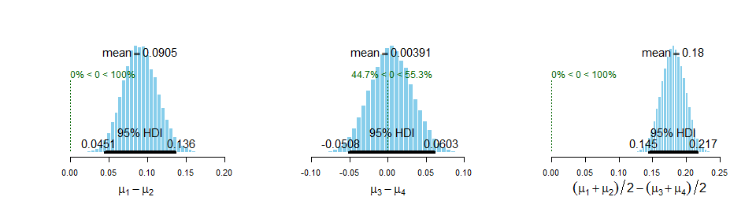

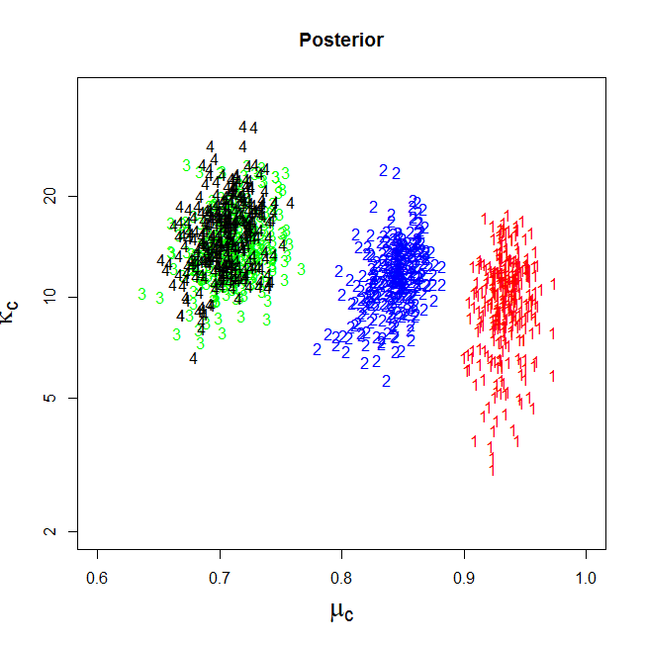

Scatterplot of ${ K}_{c}$ Versus ${ μ}_{c}$ with

${ K}_{c}$ Informed by Common Distribution

**(9.3)**

The graphs of the chains generated for the four kappas are shown below. The kappa values are mutually informed by the overarching distribution set in exercise 9.2B. Although the chains converge relatively quickly to their final regions, it does take more than 100 steps for chains to fully diverge from their equal starting values. The chains move together, which is particularly evident in the blue and red chains, until approximately 200 iterations have passed. Increasing the burn-in period would remedy this issue.

There are several signs of high autocorrelation. For example, both the red and blue chains appear stuck after approximately 75 iterations until approximately 200. Similar steaks of highly dependent values can be seen after approximately 500 and 700 iterations. Autocorrelation plots for the four kappas, shown below, confirm that high levels of autocorrelation are present. This highlights the need for thinning to reduce the dependencies between values in each chain. 